-----------

URL : http://www.greenstechnologys.com/

NOTE: Go to down of the webpage using scrolldown and print the line

"Greens Technologies Porur

149, 1C/1D, 1st Floor,

Opp to DLF IT Park,

Ramapuram,

Chennai - 600089."

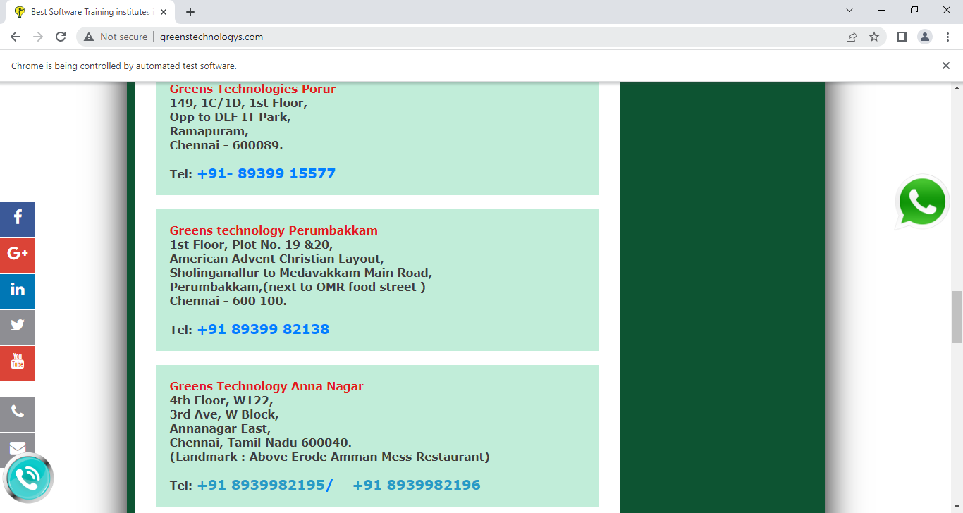

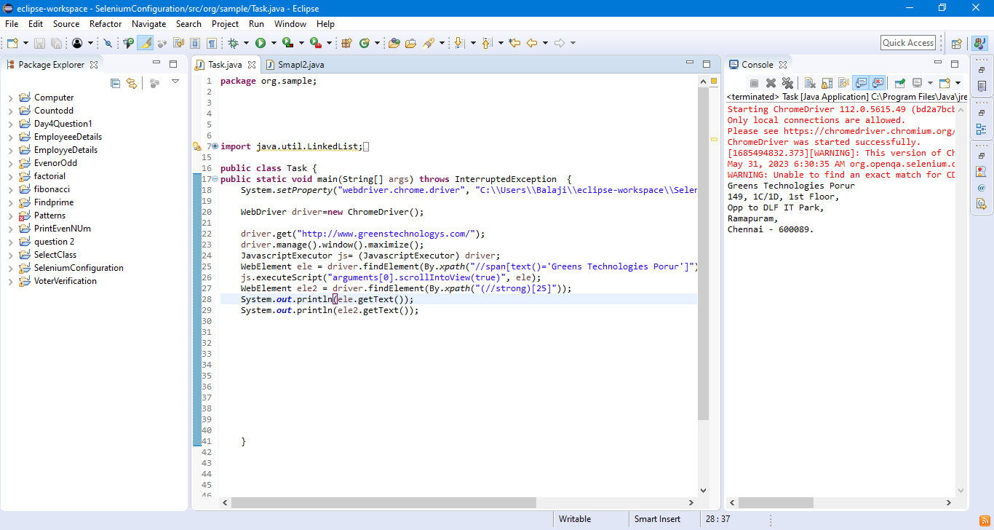

-----------

URL : http://toolsqa.com/

NOTE: Go to "Share this page" using scrolldown and again "Latest Tutorials" using scrollup.

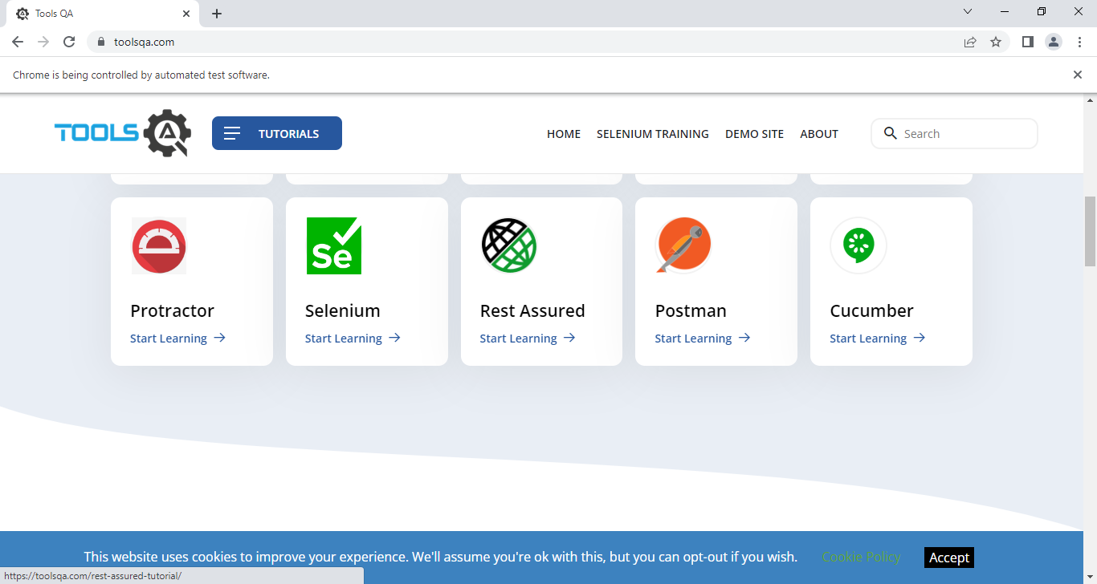

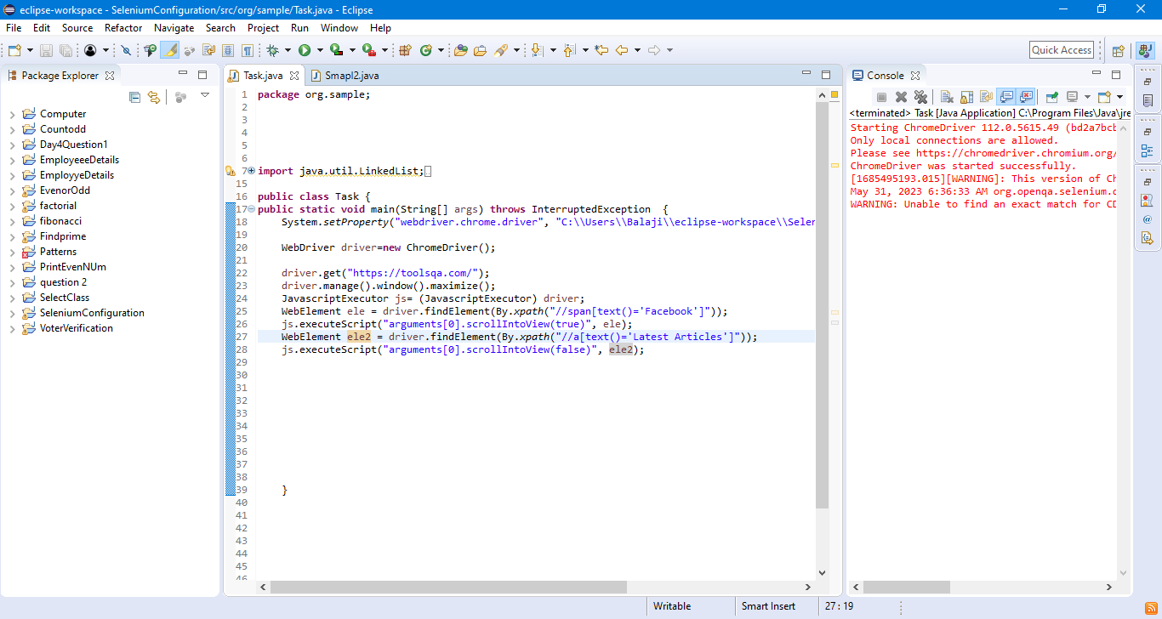

-----------

URL : http://greenstech.in/selenium-course-content.html

NOTE: Scroll Till Framework Test Papers

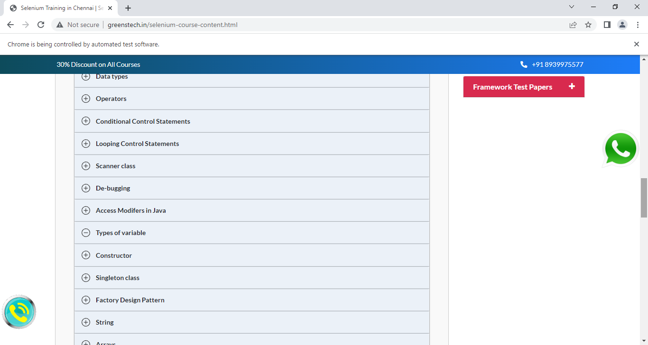

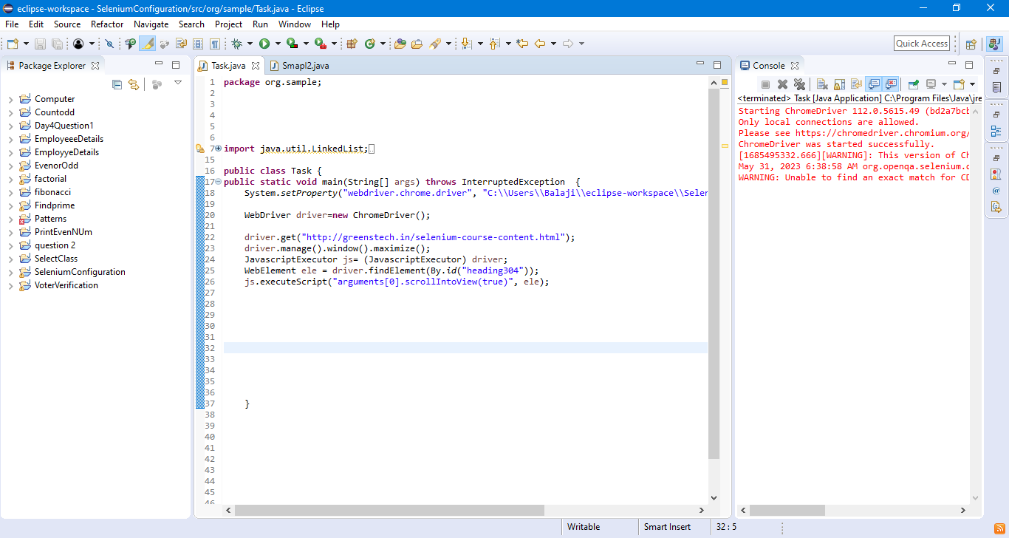

-----------

URL : https://www.facebook.com/

NOTE: Enter the email & password and click login button using JavaScript.

